EXPERIMENT 6 — Operators and Aggregate Functions
AIM:
To study SQL operators and aggregate functions such as IN, BETWEEN, AVG, MAX, MIN, SUM, and COUNT.
PROCEDURE:
- Insert vehicle records into the VEHICLE table.
- Display all vehicle records.
- Use the IN operator to filter vehicles by fuel type.
- Use BETWEEN to filter vehicles based on price.
- Calculate the average vehicle price using AVG().
- Find the maximum and minimum prices using MAX() and MIN().
- Calculate the total price using SUM().
- Count the total number of vehicles using COUNT().
- Calculate average price and vehicle count based on fuel type using GROUP BY.
OUT: 1
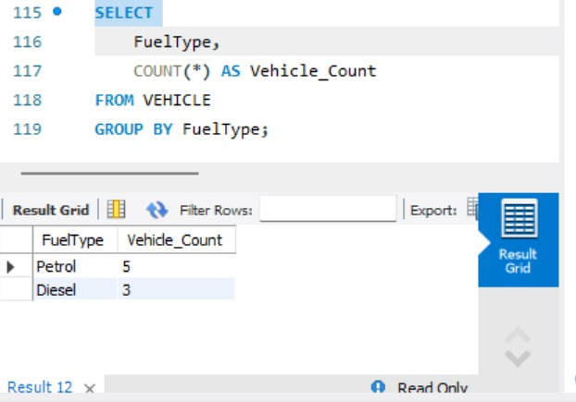
OUT: 2
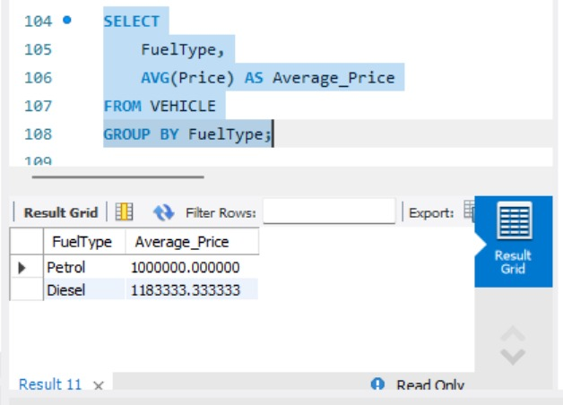
OUT:3
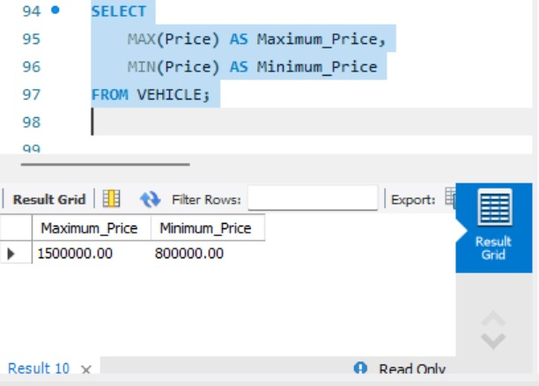
OUT : 4
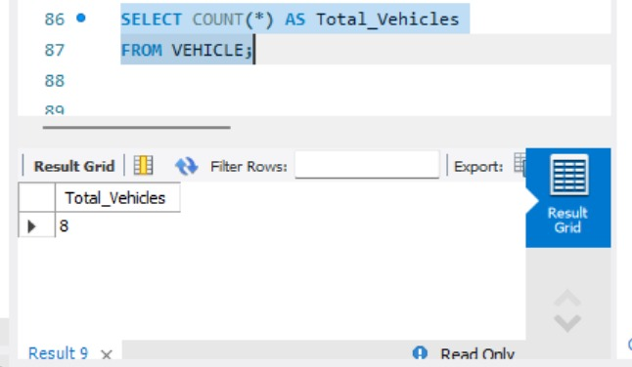
OUT: 5
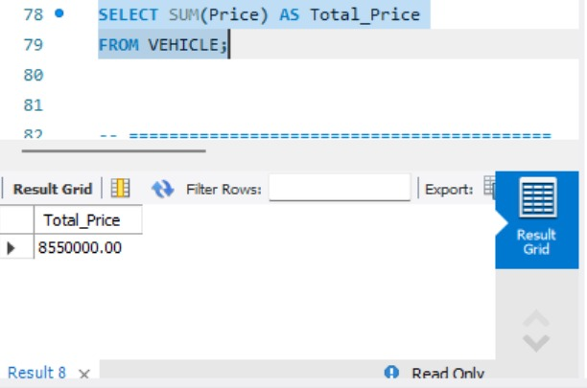
OUT : 6
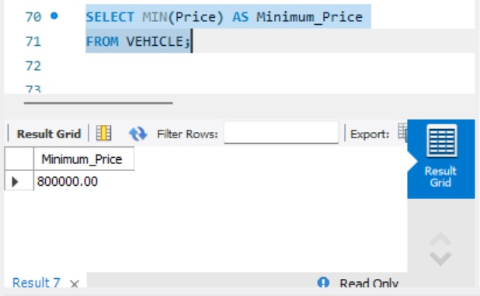
OUT: 7

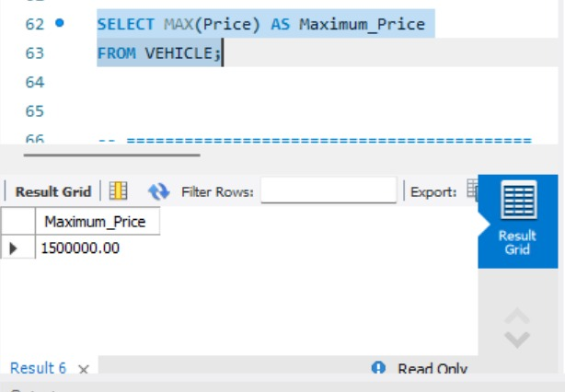
OUT : 8
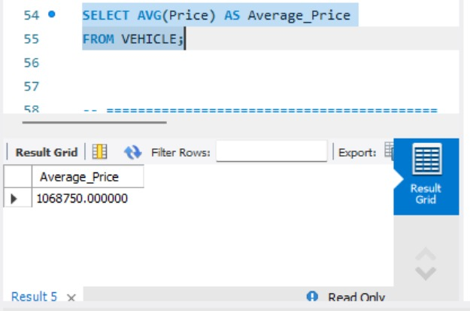
OUT: 9
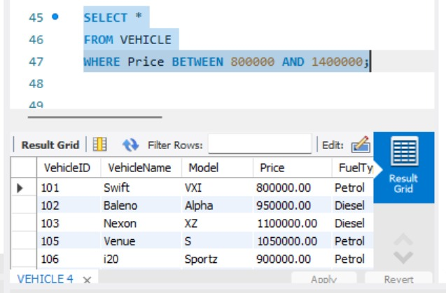
OUT : 10
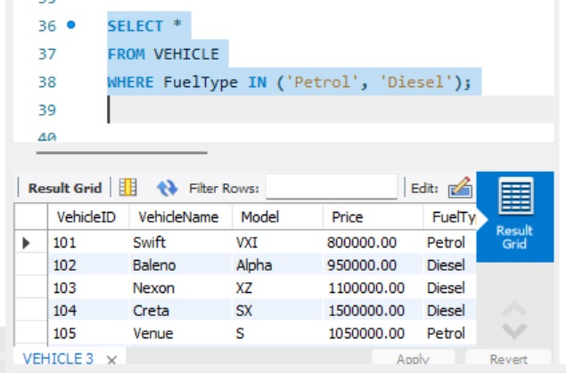
OUT : 11
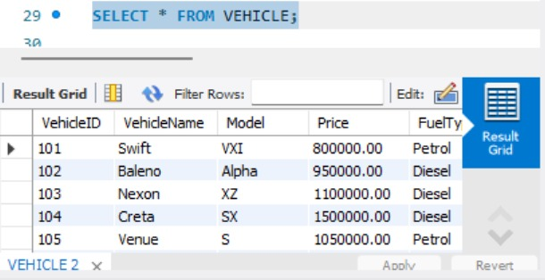
OUT :12
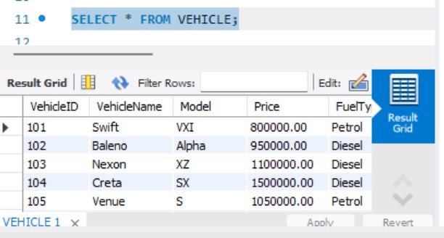
QUERY:
USE AUTOHUB_SHOWROOM;
-- ==========================================
-- VEHICLE TABLE
-- ==========================================
-- If VEHICLE table already contains records,
-- first check the records
SELECT * FROM VEHICLE;
-- Insert 8 showroom vehicle records
INSERT INTO VEHICLE
(VehicleID, VehicleName, Model, Price, Color, FuelType)
VALUES
(101, 'Swift', 'VXI', 750000, 'White', 'Petrol'),
(102, 'Baleno', 'Alpha', 950000, 'Blue', 'Petrol'),
(103, 'Nexon', 'XZ', 1100000, 'Black', 'Diesel'),
(104, 'Creta', 'SX', 1500000, 'White', 'Diesel'),
(105, 'Venue', 'S', 1050000, 'Red', 'Petrol'),
(106, 'i20', 'Sportz', 900000, 'Grey', 'Petrol'),
(107, 'Verna', 'SX', 1400000, 'Black', 'Petrol'),
(108, 'Punch', 'Adventure', 850000, 'Blue', 'Petrol');
-- Display all records
SELECT * FROM VEHICLE;
-- ==========================================
-- 1. IN OPERATOR
-- ==========================================
SELECT *
FROM VEHICLE
WHERE FuelType IN ('Petrol', 'Diesel');
-- ==========================================
-- 2. BETWEEN OPERATOR
-- ==========================================
SELECT *
FROM VEHICLE
WHERE Price BETWEEN 800000 AND 1400000;
-- ==========================================
-- 3. AVG FUNCTION
-- ==========================================
SELECT AVG(Price) AS Average_Price
FROM VEHICLE;
-- ==========================================
-- 4. MAX FUNCTION
-- ==========================================
SELECT MAX(Price) AS Maximum_Price
FROM VEHICLE;
-- ==========================================
-- 5. MIN FUNCTION
-- ==========================================
SELECT MIN(Price) AS Minimum_Price
FROM VEHICLE;
-- ==========================================
-- 6. SUM FUNCTION
-- ==========================================
SELECT SUM(Price) AS Total_Price
FROM VEHICLE;
-- ==========================================
-- 7. COUNT FUNCTION
-- ==========================================
SELECT COUNT(*) AS Total_Vehicles
FROM VEHICLE;
-- ==========================================
-- 8. MAXIMUM AND MINIMUM PRICE
-- ==========================================
SELECT
MAX(Price) AS Maximum_Price,
MIN(Price) AS Minimum_Price
FROM VEHICLE;
-- ==========================================
-- 9. AVERAGE PRICE BY FUEL TYPE
-- ==========================================
SELECT
FuelType,
AVG(Price) AS Average_Price
FROM VEHICLE
GROUP BY FuelType;
-- ==========================================
-- 10. COUNT VEHICLES BY FUEL TYPE
-- ==========================================
SELECT
FuelType,
COUNT(*) AS Vehicle_Count
FROM VEHICLE
GROUP BY FuelType;
RESULT:
Thus, SQL operators and aggregate functions were successfully executed to obtain the required vehicle statistics.

